**North West Children’s Cancer Operational Delivery Network (NWCCODN) Regional Incident Reporting Guidance**

In response to the 2021 NHS Service Specification for Children’s Cancer which states that the network should:

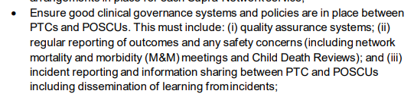

The NWCCODN have considered their role in network wide governance with respect to patient safety. This guidance is a summary of actions required for any incidents in relation to Children’s Cancer that should be escalated to the NWCCODN for network wide learning. This does not negate the need for following the in-house incident reporting policy local to your trust. Please ensure that you always follow your Individual Hospital Trust in house policies for acute management of all incidents in addition to sharing with the network those relevant to learning.

This guideline is aimed at Paediatric Oncology Shared Care Units (POSCU) and Principal Treatment Centre’s (PTC’s) within the North West Region and relates to incidents involving patients aged 0-16 years inclusive. Cancer care related incidents reported within trust incident reporting systems should be escalated to the NWCCODN Senior Leadership Team (SLT) when the incident is likely to be considered ‘significant harm’ or where the incident or learning is considered relevant for network (NWCCODN) support with actions or disseminating shared learning. The SLT team will consider a range of options including promotion of a network wide safety bulletin, bespoke meetings to support joint team discussion, relevance to current NWCCODN policies and pathways and presentation of an anonymised incident summary at the Network Oversight Group (NOG).

Example incidents may include (but are not limited to) chemotherapy related incidents to network shared care, Patient harm arising from transfer or transport of patients, Complaints relating to communications between POSCU/PTC or Issues arising from Morbidity & Mortality (M&M) meetings relevant for network learning/ shared good practise.

|  |
| --- |
| **How to escalate incidents to the NWCCODN** |
| Communication of incidents to the SLT team is to be directed via email to the network generic email address [info.nwccodn@mft.nhs.uk](mailto:info.nwccodn@mft.nhs.uk).with a copy of incident relevant documentation and local consideration and action plan.  The ODN may contribute to the trust incident investigation process as appropriate and can support independent investigation if required. |

*Please note where appropriate some incidents may need to be escalated to NHSE Programme of Care Group and the NHSE Quality Team via the ODN. This will be carried out by the ODN.*